**Results and Performances**

1. **Tweet lengths of different languages showing the minimum, maximum and average text length for each language.**

**Query:**

db.tweets.aggregate([ { $group: { _id: "$language", minimum: { $min: { $strLenCP: "$tweet_text" } }, maximum: { $max: { $strLenCP: "$tweet_text" } }, average: { $avg: { $strLenCP: "$tweet_text" } } } }, { $project: { Language: "$_id", Minimum: "$minimum", Maximum: "$maximum", Average: { $round: ["$average", 2] } } }, { $sort: { Average: -1 } }]);

**Result:**

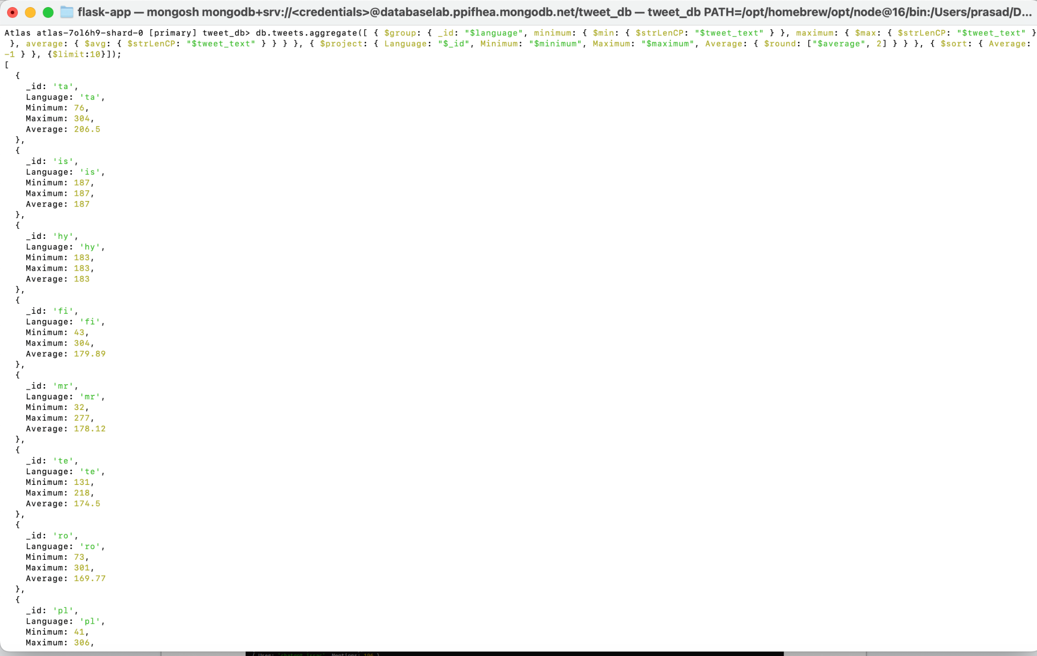

**Performance:  
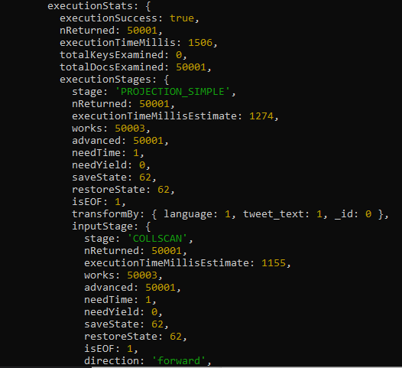**

**SQL Query Performance:**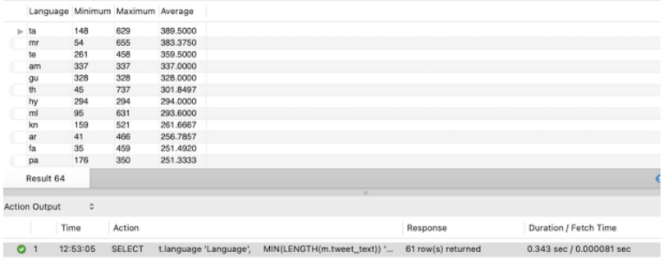

1. **Total tweets about chat gpt on each day from the dataset**

**Query:**

db.tweets.aggregate([ { $group: {_id: { $dateToString: { format: "%d-%m-%Y", date: {$toDate: "$datetime" } }},count: { $sum: 1 } } }, { $project: {_id: 0,Tweet_date: "$_id","No of tweets per day": "$count" } }, { $sort: {Tweet_date: 1 } }]);

**Result:**

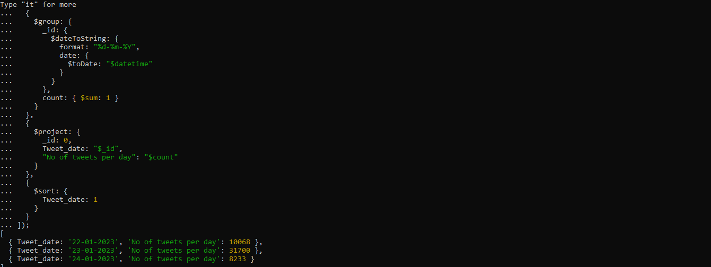

**Performance:**

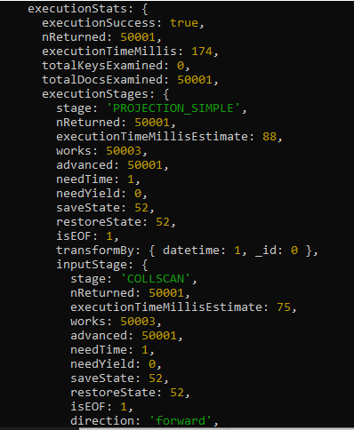

**SQL Query Performance:**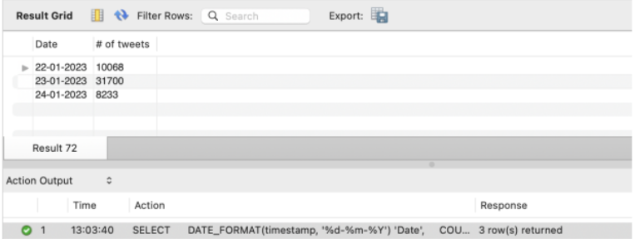

**3. Top 3 Viral tweets and its details based on retweet counts.**

**Query** -

db.tweets.find({}, {

"user.name": 1,

"tweet_text": 1,

"counts.retweet": 1,

"media_type" :1,

"quoted_tweet": 1})

.sort({"counts.retweet":-1})

.limit(3)

**Result:**

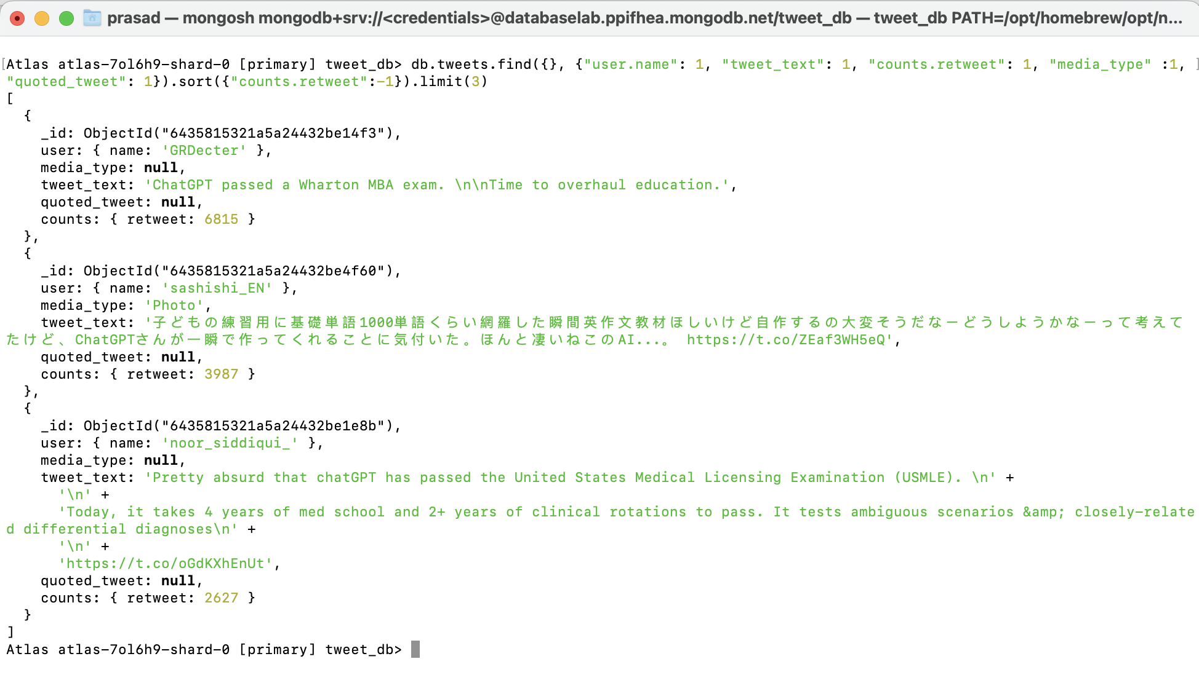

**Performance:  
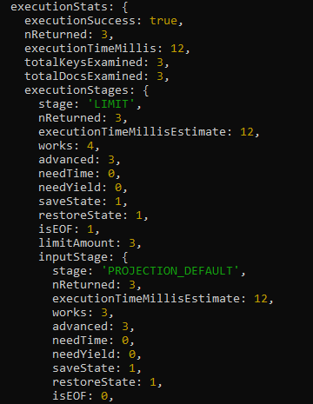**

**SQL Query Performance:**

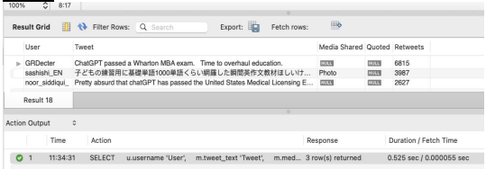

**4. The most favorable media (photo/video/gif) used in chat gpt related tweets based on likes.**  
**Query** -

db.tweets.aggregate([ { $match: { "media_type": { $ne: null } } }, { $group: { _id: { "media_type": "$media_type" }, Likes: { $sum: "$counts.like" }, Retweets: { $sum: "$counts.retweet" }, Quoted: { $sum: "$counts.quote" } } }, { $sort: { "Likes": -1, "Retweets": -1, "Quoted": -1 } }])

**Result:**  
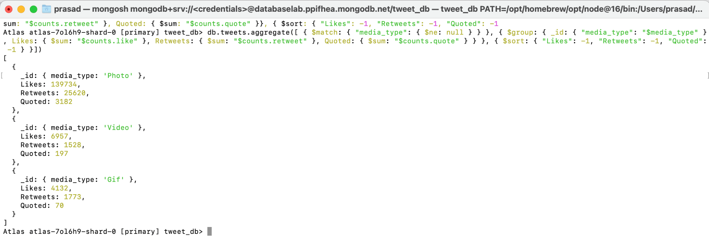

**Performance:**

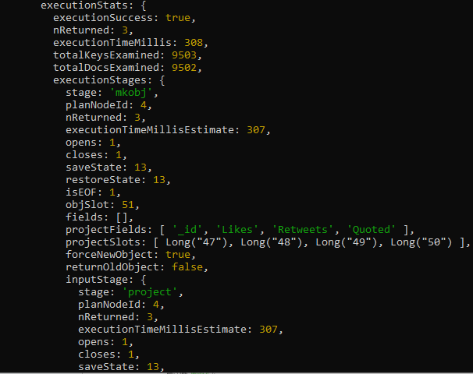

**SQL Query Performance:**

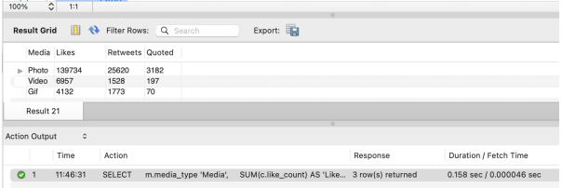

**5. The top 5 most preferred sources of twitter to tweet during the time period from the dataset.  
Query** -

db.tweets.aggregate([ { $group: { _id: { "source": "$source" }, Count: { $sum: 1 } } }, { $sort: { Count: -1 } }, { $limit: 5 }])

**Result:**

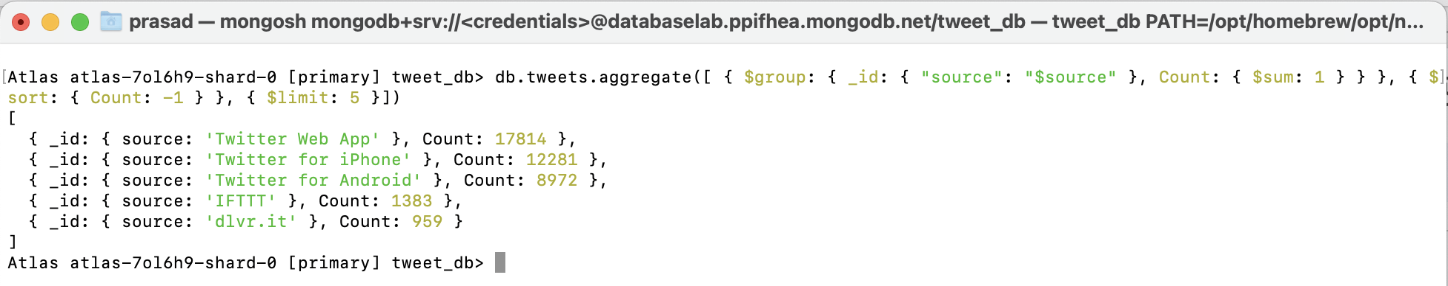  
**Performance:**

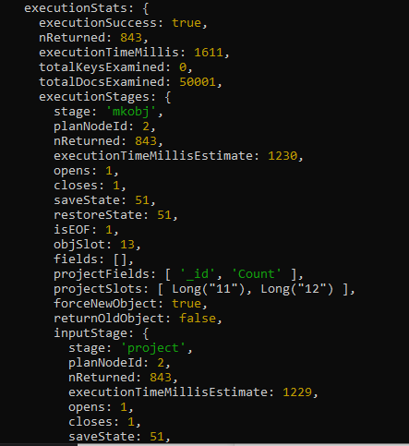

**SQL Query Performance:**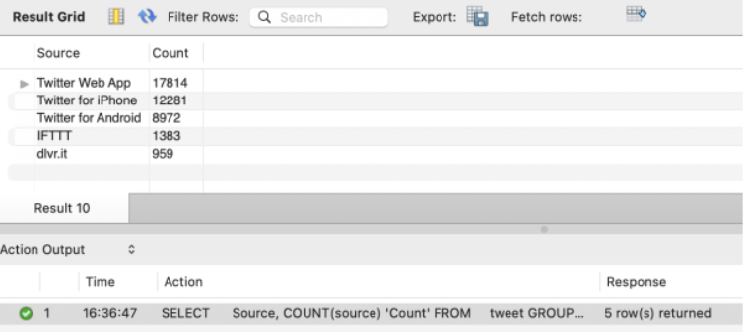

**6. The top 10 most mentioned twitter users in chat gpt related tweets.**  
**Query:**  
db.tweets.aggregate([{ $unwind: "$mentioned_users" },{ $group: { _id: "$mentioned_users", count: { $sum: 1 } } },{ $sort: { count: -1 } },{ $limit: 10 },{ $project: { _id: 0, User: "$_id", MentMentions: "$count" } }])

**Result:**  
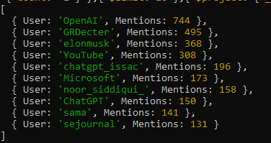

**Performance:**

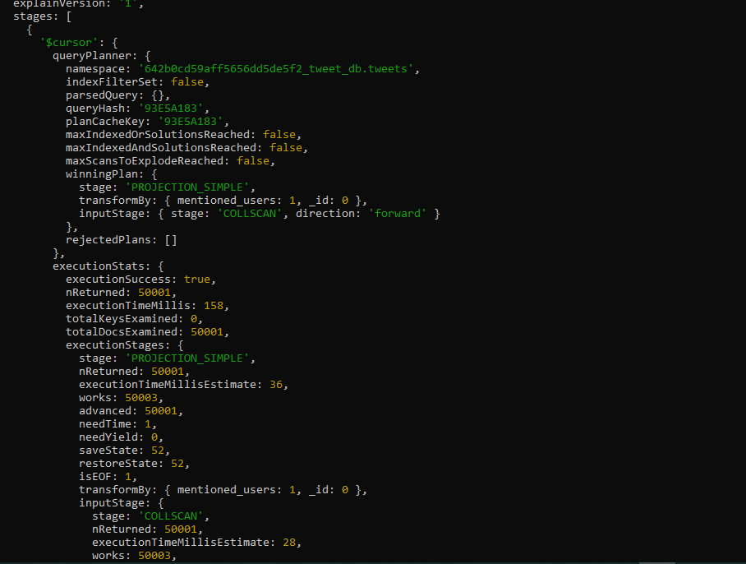

**SQL Query Performance:**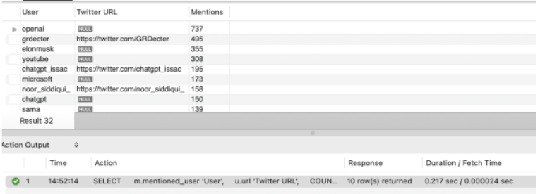

**7. Hashtag statistics - The minimum, maximum and average number of hashtags used in all the tweets from the dataset.**

**Query:**

db.tweets.aggregate([{ $project: { num_hashtags: { $size: { $ifNull: ["$hashtags", []] } } } },{ $group: { _id: null, min_hashtags: { $min: "$num_hashtags" }, max_hashtags: { $max: "$num_hashtags" }, avg_hashtags: { $avg: "$num_hashtags" } } }])  
  
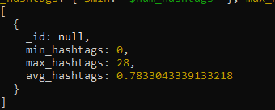

**Performance:**

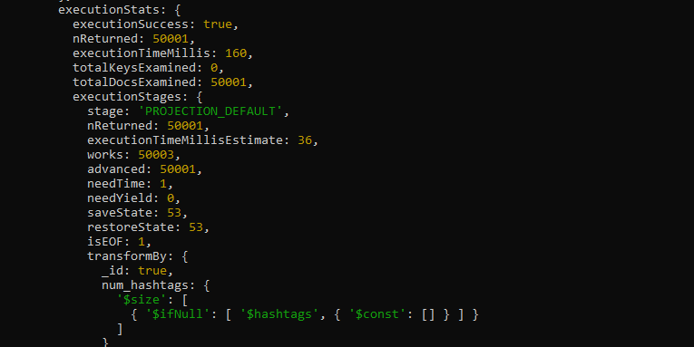

**SQL Query Performance:**

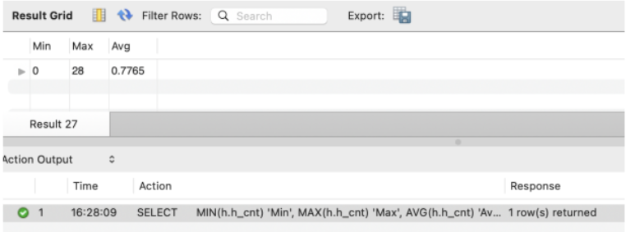

**8. Top 5 most quoted tweeted tweets and its users:**

**Query:**

db.tweets.aggregate([

{

$group: {

_id: { "Quoted_Tweet": "$quoted_tweet" },

Count_of_Quoted_Tweet: { $sum: 1 },

User: { $first: "$user.name" },

TweetText: { $first: "$text" }

}

},

{ $sort: { Count: -1 } },

{ $limit: 5 }

])  
**Result:**  
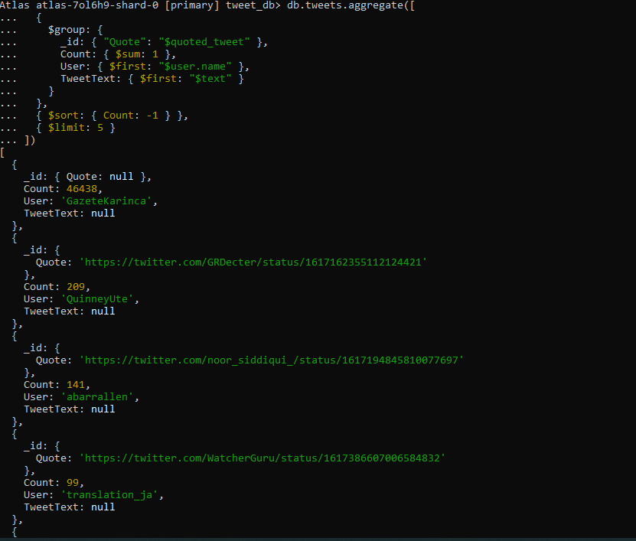  
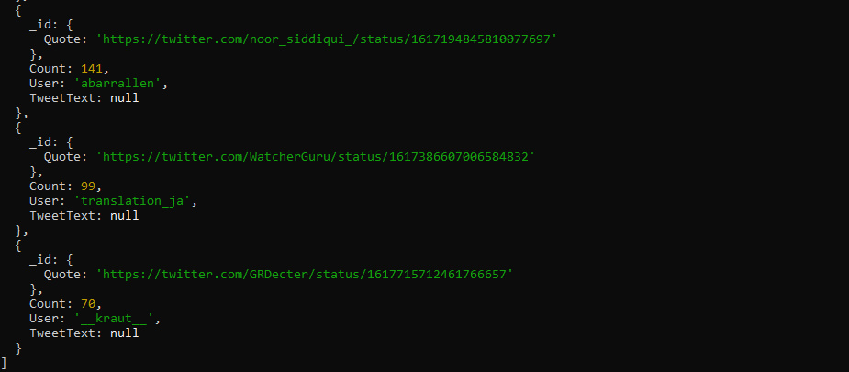  
**Performance:**

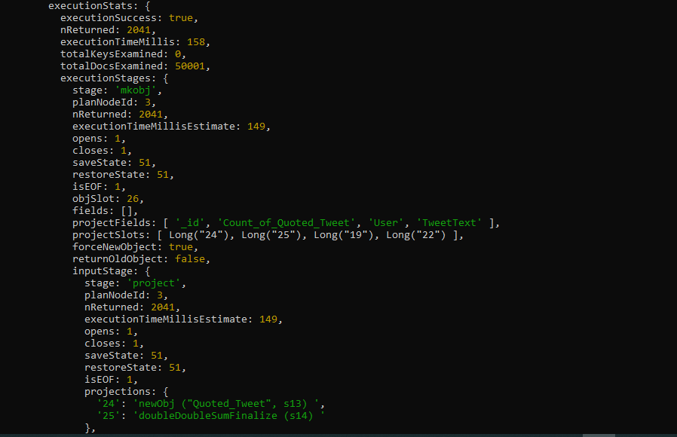

**SQL Query Performance:**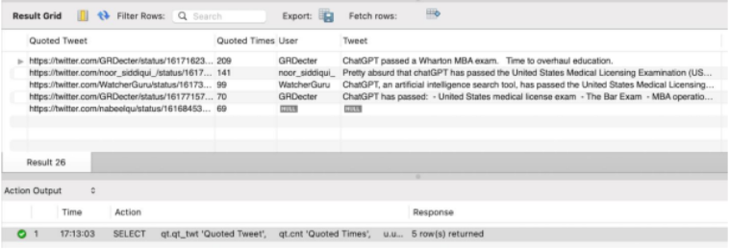

**9. Top 3 Outlinks**

**Query:**

db.tweets.aggregate([ { $match: { outlinks: { $nin: [null], $not: /twitter\.com/ } } }, { $group: { _id: "$outlinks", count: { $sum: 1 } } }, { $sort: { count: -1 } }, { $limit: 3 }, { $project: { _id: 0, content: "$_id", count: 1 } }]).pretty();

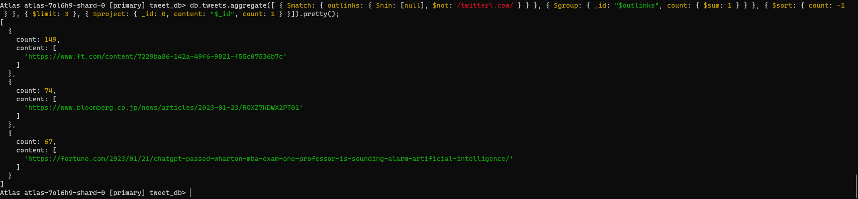  
**Performance:**

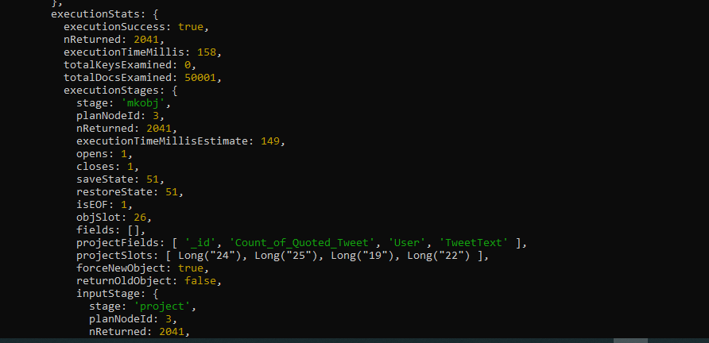

**SQL Query Performance:**

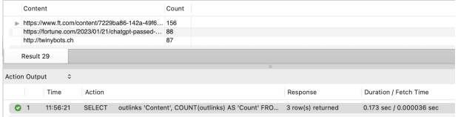

**10. Top 5 languages used to tweet about chatGPT**

**Query:**

db.tweets.aggregate([ { $match: { language: { $ne: null } } }, { $group: { _id: "$language", count: { $sum: 1 } } }, { $sort: { count: -1 } }, { $limit: 5 }, { $project: { _id: 0, Language: "$_id", "# of Tweets": "$count" } }])  
**Result:**  
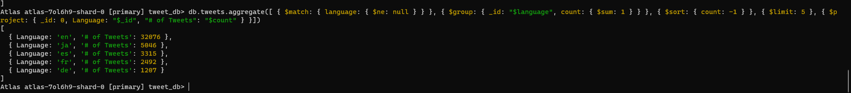

**Performance:  
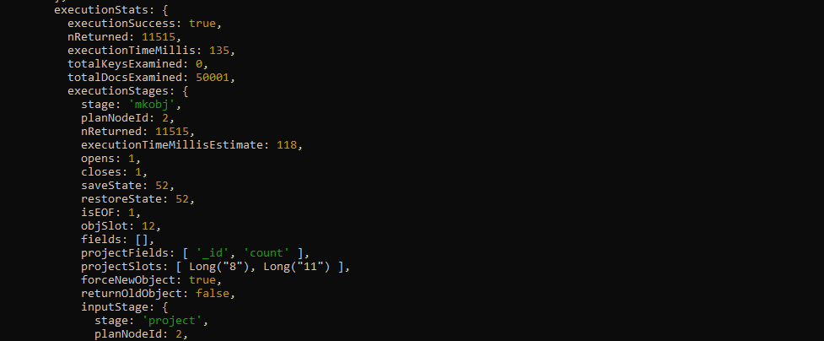**

**SQL Query Performance:**  
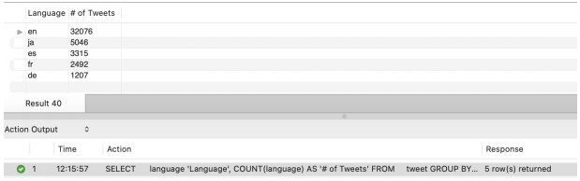

**11. Top 10 hashtags used for chat gpt related tweets and their counts from the dataset.**

**Query:**

db.tweets.aggregate([ { $group: { _id: { "hashtags": "$hashtags" }, Count: { $sum: 1 } } }, { $sort: { Count: -1 } }, { $limit: 10 }]);

**Result:**  
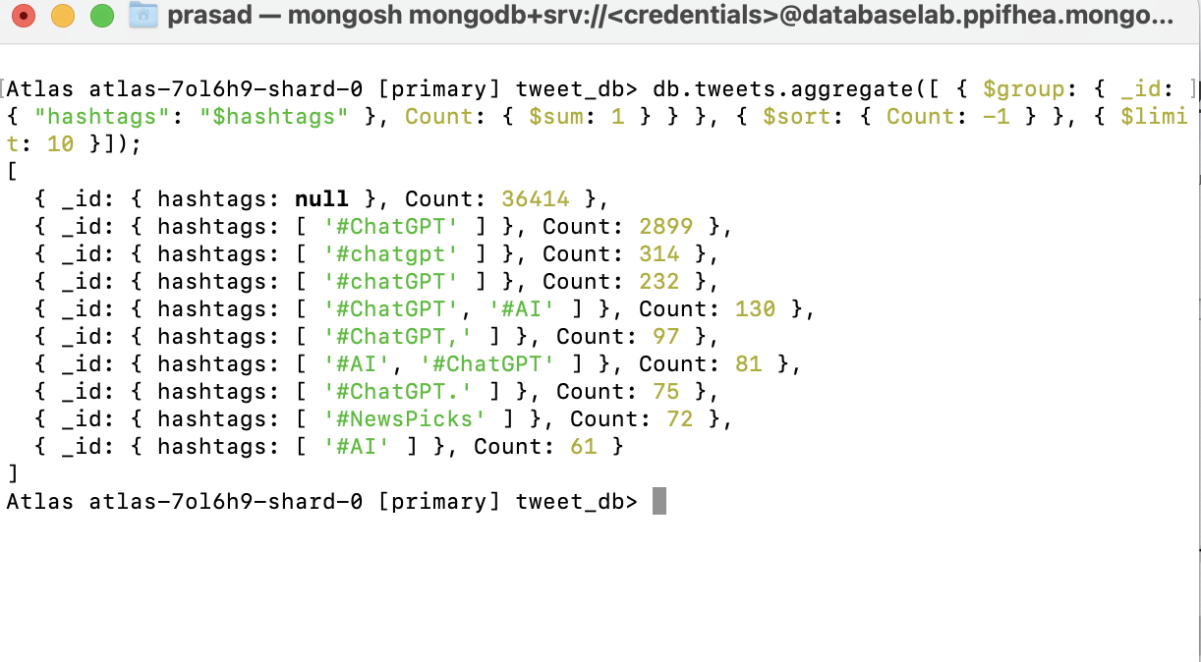

**Performance:**  
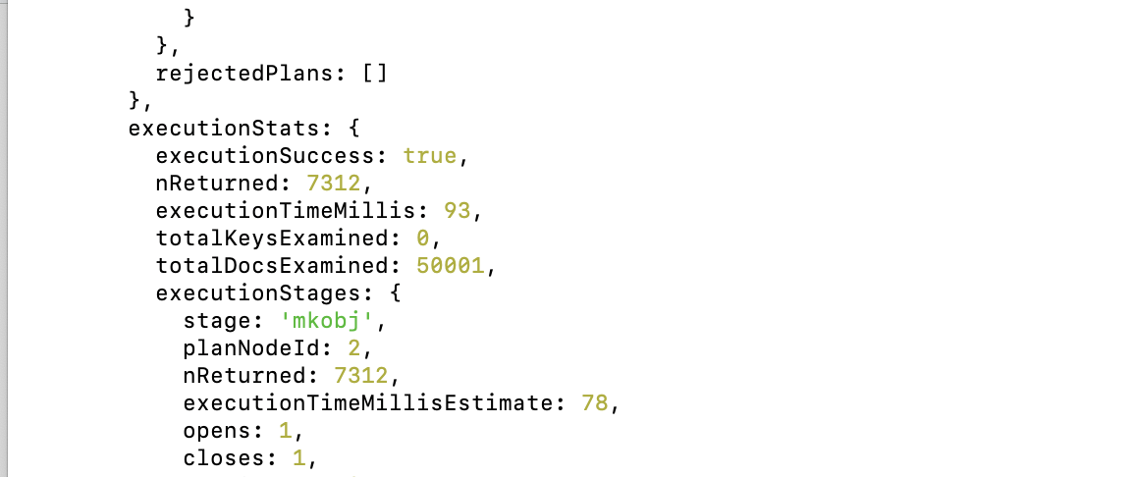

**SQL Query Performance:**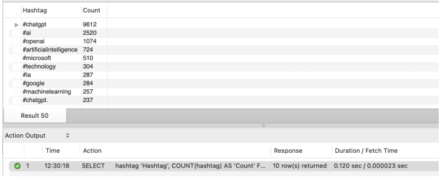

**12. Information about the longest tweet text about chat gpt from the dataset.**

**Query:**

db.tweets.aggregate([ { $group: { _id: "$tweet_text", maximum: { $max: { $strLenCP: "$tweet_text" } } } }, { $project: {_id: 0, Tweet: "$_id", Maximum: "$maximum" } }, { $sort: { Maximum: -1 } },{$limit:1}]);

**Result:**

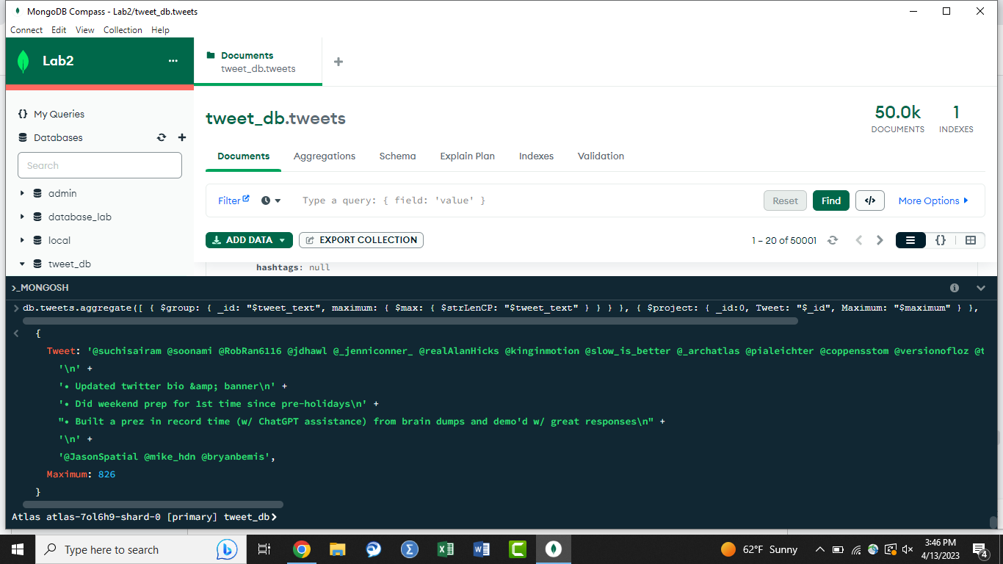  
  
**Performance:**

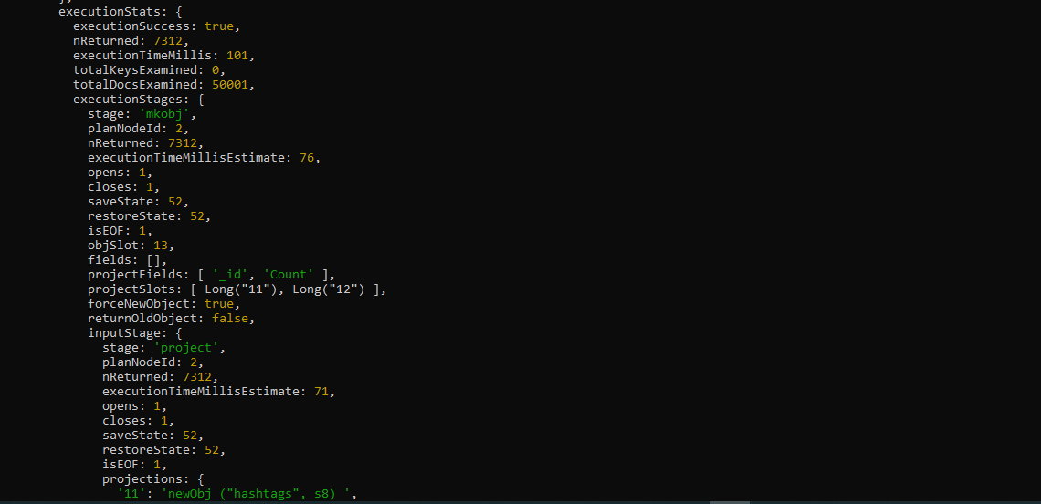

**SQL Query Performance:**

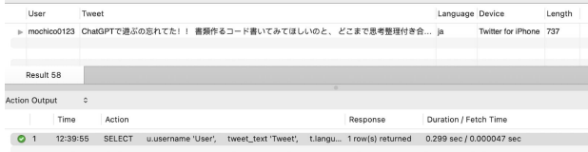

**13. Peak hours of Activity**

**Query:**

db.tweets.aggregate({ "$project": {"h":{"$hour":"$datetime"}, "tweet_id":1 }}, { "$group":{ "_id": { "hour":"$h"},'count':{$sum:1} }}, {"$sort":{count:-1}});  
  
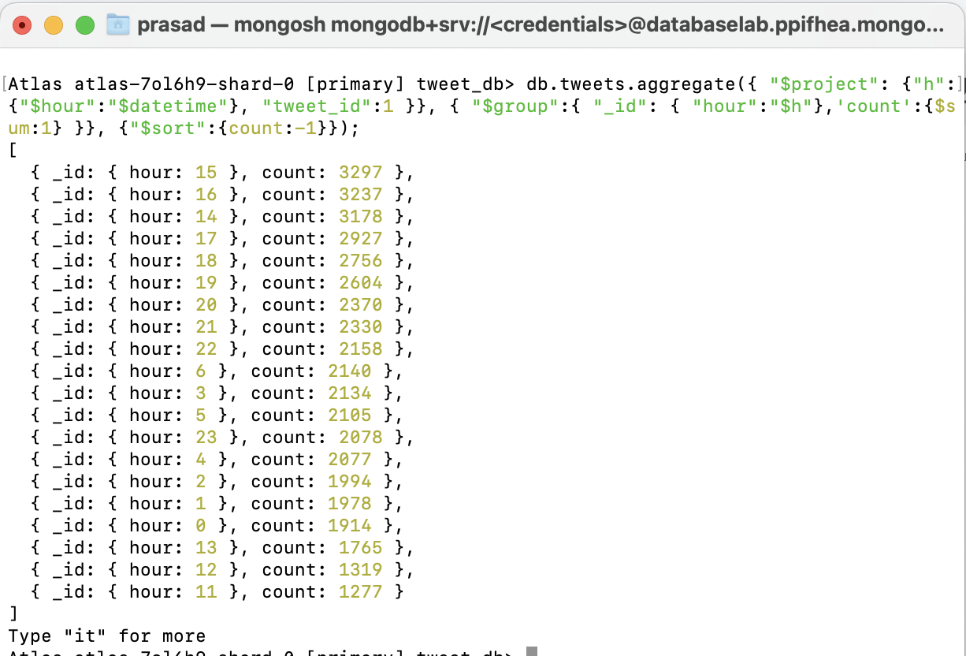  
**Performance:**  
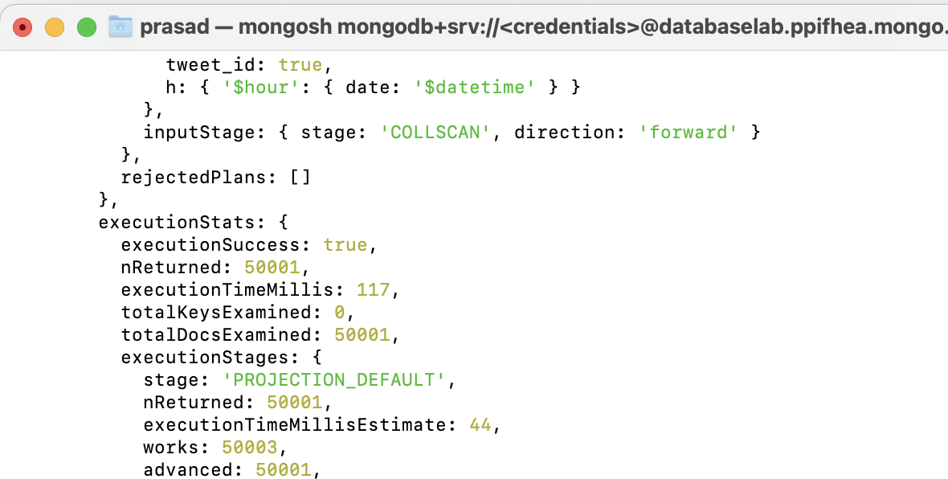

**SQL Query Performance:**